Zadanie

W obwodzie jak na schemacie poniżej obliczyć wszystkie prądy oraz napisać równania opisujące ich wartości chwilowe. Wykorzystać metodę liczb zespolonych.

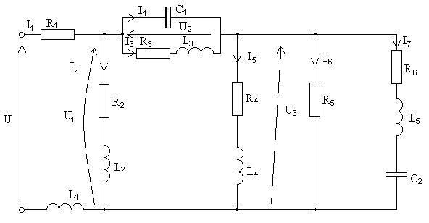
Dane
$$u=\sqrt{2}⋅\text{230sin}(\text{314t}−{\text{30}}^{∘})V$$
$R_{1}=\text{10}Ω$ $L_{1}=\text{95,5mH}$ $C_{1}=\text{79,6}μF$
$R_{2}=\text{20}Ω$ $L_{2}=1\text{27}\text{mH}$ $C_{2}=63,7μF$
$R_{3}=\text{40}Ω$ $L_{3}=1\text{27}\text{mH}$
$R_{4}=\text{80}Ω$ $L_{4}=\text{159mH}$
$R_{5}=\text{100}Ω$ $L_{5}=3\text{18}\text{mH}$
$$R_{6}=\text{50}Ω$$

Rozwiązanie

$$X_{\text{L1}}=ω⋅L_{1}=\text{314}⋅\text{95},5⋅{\text{10}}^{−3}=30Ω$$
$$X_{\text{L2}}=ω⋅L_{2}=\text{314}⋅\text{127}⋅{\text{10}}^{−3}=40Ω$$
$$X_{\text{L3}}=ω⋅L_{3}=\text{314}⋅\text{127}⋅{\text{10}}^{−3}=40Ω$$
$$X_{\text{L4}}=ω⋅L_{4}=\text{314}⋅\text{159}⋅{\text{10}}^{−3}=\text{50}Ω$$
$$X_{\text{L5}}=ω⋅L_{5}=\text{314}⋅\text{318}⋅{\text{10}}^{−3}=1\text{00}Ω$$
$$X_{\text{C1}}=\frac{1}{ω⋅C_{1}}=\frac{1}{\text{314}⋅\text{79},6⋅{\text{10}}^{−6}}=\text{40}Ω$$

$$X_{\text{C2}}=\frac{1}{ω⋅C_{2}}=\frac{1}{\text{314}⋅\text{63,7}⋅{\text{10}}^{\text{-6}}}=\text{50}Ω$$

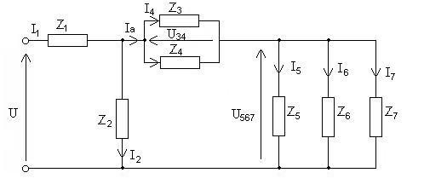

Obliczamy impedancję zespoloną każdej gałęzi i zastępujemy ją na schemacie symbolem w celu uproszczenia schematu.
$${\underline{Z}}_{1}=R_{1}+{\text{jX}}_{\text{L1}}=(\text{10}+\text{j30})Ω$$
$${\underline{Z}}_{2}=R_{2}+{\text{jX}}_{\text{L2}}=(\text{20}+\text{j40})Ω$$
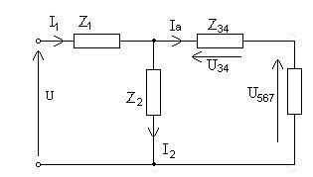
$${\underline{Z}}_{3}=R_{3}+{\text{jX}}_{\text{L3}}=(\text{40}+\text{j40})Ω$$
$${\underline{Z}}_{4}=−{\text{jX}}_{\text{C1}}=\text{-j40}Ω$$
$${\underline{Z}}_{5}=R_{4}+{\text{jX}}_{\text{L4}}=(\text{80}+\text{j50})Ω$$
$${\underline{Z}}_{6}=R_{5}=\text{100}Ω$$
$${\underline{Z}}_{7}=R_{6}+{\text{jX}}_{\text{L5}}−{\text{jX}}_{\text{C2}}=\text{50}+\text{j100-j50}Ω$$
$$\underline{Z}=(\text{50}+\text{j50})Ω$$
Wszystkie prądy obliczamy wykorzystując metodę upraszczania obwodu.
$${\underline{Z}}_{\text{34}}=\frac{{\underline{Z}}_{3}⋅{\underline{Z}}_{4}}{{\underline{Z}}_{3}+{\underline{Z}}_{4}}=\frac{(\text{40}+\text{j40})(−\text{j40})}{\text{40}+\text{j40}−\text{j40}}=(\text{40}−\text{j40})Ω$$
$$\frac{1}{{\underline{Z}}_{\text{567}}}=\frac{1}{{\underline{Z}}_{5}}+\frac{1}{{\underline{Z}}_{6}}+\frac{1}{{\underline{Z}}_{7}}=\frac{1}{\text{80}+\text{j50}}+\frac{1}{\text{100}}+\frac{1}{\text{50}+\text{j50}}$$
$$\frac{1}{{\underline{Z}}_{\text{567}}}=9⋅{\text{10}}^{−3}−\text{j5,62}⋅{\text{10}}^{−3}+\text{0,01}+\text{0,01}−\text{j0,01}=(\text{0,029}−\text{j0,0156})S$$
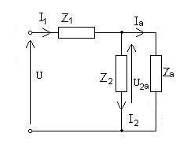
$${\underline{Z}}_{\text{567}}=\frac{1}{\text{0,029}}−\text{j0,0156}=(\text{26,74}+\text{j14,4})Ω$$
$${\underline{Z}}_{a}={\underline{Z}}_{\text{34}}+{\underline{Z}}_{\text{567}}=\text{40}−\text{j40}+\text{26,74}+\text{j14,4}$$
$${\underline{Z}}_{a}=(\text{66,74}−\text{j25,6})Ω$$
$${\underline{Z}}_{\text{2a}}=\frac{{\underline{Z}}_{2}⋅{\underline{Z}}_{a}}{{\underline{Z}}_{2}+{\underline{Z}}_{a}}\frac{(\text{20}+\text{j40})(\text{66,74}−\text{j25,6})}{\text{20}+\text{j40}+\text{66,74}−\text{j25,6}}$$
$${\underline{Z}}_{\text{2a}}=(\text{30,48}+\text{j19,81})Ω$$
$$\underline{Z}={\underline{Z}}_{1}+{\underline{Z}}_{a}=\text{10}+\text{j30}+\text{30,48}+\text{19,81}$$
$$\underline{Z}=(\text{40,48}+\text{j49,81})Ω={\text{64,18e}}^{{\text{j50,9}}^{∘}}Ω$$
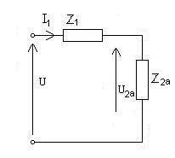
$${\underline{I}}_{1}=\frac{\underline{U}}{\underline{Z}}=\frac{{\text{230e}}^{−{\text{j30}}^{∘}}}{\text{40,48}+\text{j49,81}}={\text{3,58e}}^{−{\text{j80,9}}^{∘}}Ω$$
$$i_{1}=\sqrt{2}⋅\text{3,58sin}({\text{314t-80,9}}^{∘})A$$
$${\underline{U}}_{\text{2a}}={\underline{I}}_{1}⋅{\underline{Z}}_{\text{2a}}={\text{3,58e}}^{{\text{j80,9}}^{∘}}+(\text{30,48}+\text{j19,81})=\text{87,37}−\text{j96,62})V$$
$${\underline{I}}_{2}=\frac{{\underline{U}}_{\text{2a}}}{{\underline{Z}}_{2}}=\frac{\text{87,37}−\text{j96,62}}{\text{20}+\text{j40}}=−\text{1,06}−\text{j2,71}={\text{2,91e}}^{−{\text{j111,3}}^{∘}}A$$
$$i_{2}=\sqrt{2}⋅2,\text{91}\text{sin}({\text{314t-111,3}}^{∘})A$$
$${\underline{I}}_{a}=\frac{{\underline{U}}_{\text{2a}}}{{\underline{Z}}_{a}}=\frac{\text{87,37}−\text{j96,62}}{66,\text{74}+\text{j25,6}}=−\text{1,63}−\text{j0,82}=1,\text{82}e^{−{\text{j26,9}}^{∘}}A$$
$${\underline{U}}_{\text{34}}={\underline{I}}_{a}⋅{\underline{Z}}_{\text{34}}=(\text{1,63}−\text{j0,82})(\text{40}−\text{j40})=(\text{32,04}−\text{j98})V$$
$${\underline{I}}_{3}=\frac{{\underline{U}}_{\text{34}}}{{\underline{Z}}_{3}}=\frac{\text{32,04}−\text{j98}}{\text{40}+\text{j40}}=−\text{0,82}−\text{j1,63}={\text{1,82e}}^{−{\text{j116,9}}^{∘}}A$$
$$i_{3}=\sqrt{2}⋅\text{1,82sin}({\text{314t-116,9}}^{∘})A$$
$${\underline{I}}_{4}=\frac{{\underline{U}}_{\text{34}}}{{\underline{Z}}_{4}}=\frac{\text{32,04}−\text{j98}}{−\text{j40}}=\text{2,45}+\text{j0,8}={\text{2,58e}}^{−{\text{j116,9}}^{∘}}A$$
$$i_{4}=\sqrt{2}⋅\text{2,58sin}({\text{314t-18,1}}^{∘})A$$
$${\underline{U}}_{\text{567}}={\underline{I}}_{a}⋅{\underline{Z}}_{\text{567}}=(\text{1,63}−\text{j0,82})(\text{26,74}+\text{j14,4})=\text{55,4}+{\text{j1,55e}}^{\text{j1,6}}V$$
$${\underline{I}}_{5}=\frac{{\underline{U}}_{\text{567}}}{{\underline{Z}}_{5}}=\frac{\text{55,4}−\text{j1,55}}{\text{80}+\text{j50}}=\text{0,51}−\text{j0,3}={\text{0,59e}}^{−{\text{j30,4}}^{∘}}A$$
$$i_{5}=\sqrt{2}⋅0,\text{59}\text{sin}({\text{314t-30,4}}^{∘})A$$
$${\underline{I}}_{6}=\frac{{\underline{U}}_{\text{567}}}{{\underline{Z}}_{6}}=\frac{\text{55,4}−\text{j1,55}}{\text{100}}=\text{0,554}−\text{j0,0155}={\text{0,55e}}^{−{\text{j1,6}}^{∘}}A$$
$$i_{6}=\sqrt{2}⋅0,\text{55}\text{sin}({\text{314t-1,6}}^{∘})A$$
$${\underline{I}}_{7}=\frac{{\underline{U}}_{\text{567}}}{{\underline{Z}}_{7}}=\frac{\text{55,4}−\text{j1,55}}{\text{50}+\text{j50}}=\text{0,57}−\text{j0,54}={\text{0,78e}}^{{\text{-j43,4}}^{∘}}A$$
$$i_{6}=\sqrt{2}⋅0,\text{78}\text{sin}({\text{314t-43,4}}^{∘})A$$

